USER GUIDE

|  |  |
| --- | --- |
|  | **Group Member:-**   * Syed Zohaib Hussain(Group Leader) * Muhammad Nabeel Tariq * Muntaha * Najeeb Ahmed * Syed Muhammad Danish Ali |

|  |  |  |
| --- | --- | --- |
| **S.No** | **Content** | **Pg. No** |
| **1** | **Acknowlegdment** | **2** |
| **2** | **Introduction Of App** | **3** |
| **3** | **Requirment Specification** | **3** |
| **4** | **Project Duration** | **4** |
| **5** | **Task Sheet** | **5** |
| **6** | **Snapshot** | **6** |

**CONTENT**

**SITE** **MAP**

0

CITIES

WONDERS

Beirut

Durban

La Paz

Doha

Havana

Vigan

Kuala Lumpur

Great Barrier Reef

Deep-Sea Vents

Lake Baikal

Iguazu Falls

Hạ Long

Jeju Island

Table Mountain

Puerto Princesa Underground River

Amazon rainforest

Komodo

Machu   
Picchu

Christ the Redeemer

Great Wall of China

Petra

Colosseum

Taj Mahal

Chichen  
Itza

Belize Barrier Reef

Palau

Northern Red Sea

Galápagos Islands

Victoria  
Falls

Paricutlin  
Volcano

Mount  
Everest

Grand  
Canyon

Aurora

[Great Barrier  
Reef](https://en.wikipedia.org/wiki/Great_Barrier_Reef)

[Harbor](https://en.wikipedia.org/wiki/Guanabara_Bay) of [Rio de Janeiro](https://en.wikipedia.org/wiki/Rio_de_Janeiro)

UNDER WATER

WONDERS

NATURE

WONDERS

NATURAL

WONDERS

NEW

WONDERS

WONDERS

MAPS

Home

**SNAP SHOTS**

# 1)Loading Page:-

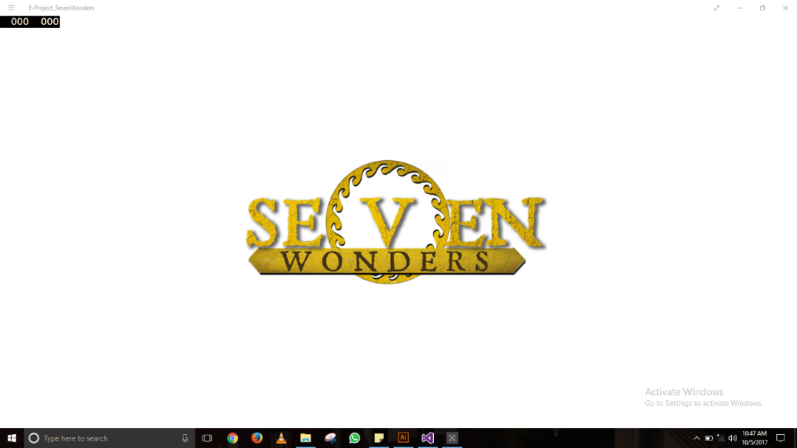

**2)Home Page**

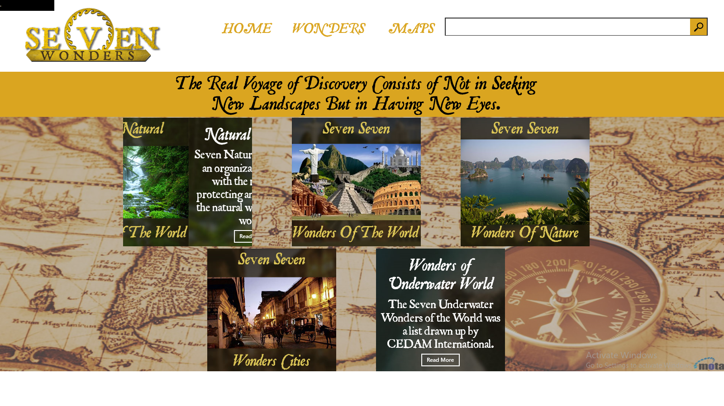

**Here You Can go into our Category of Wonders & search Section is going help to find your Desire Wonders Every Category have their own & wonders deepending on their Features**

